1.

SELECT count(\*) FROM [Customers] where Country = 'Germany'

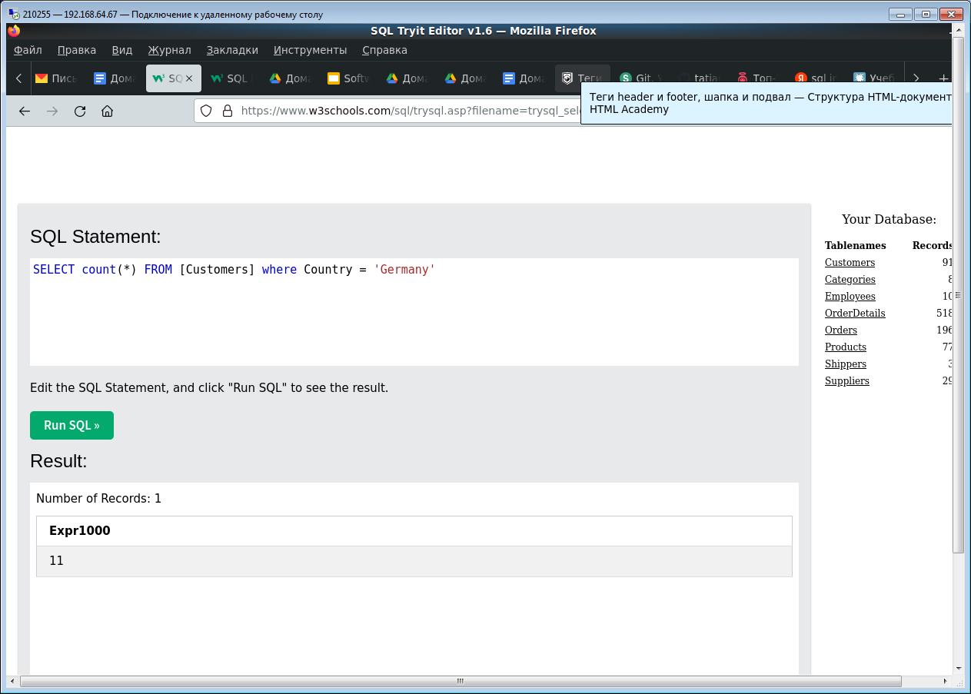

2.

SELECT \* FROM Customers where CustomerName like '%e'

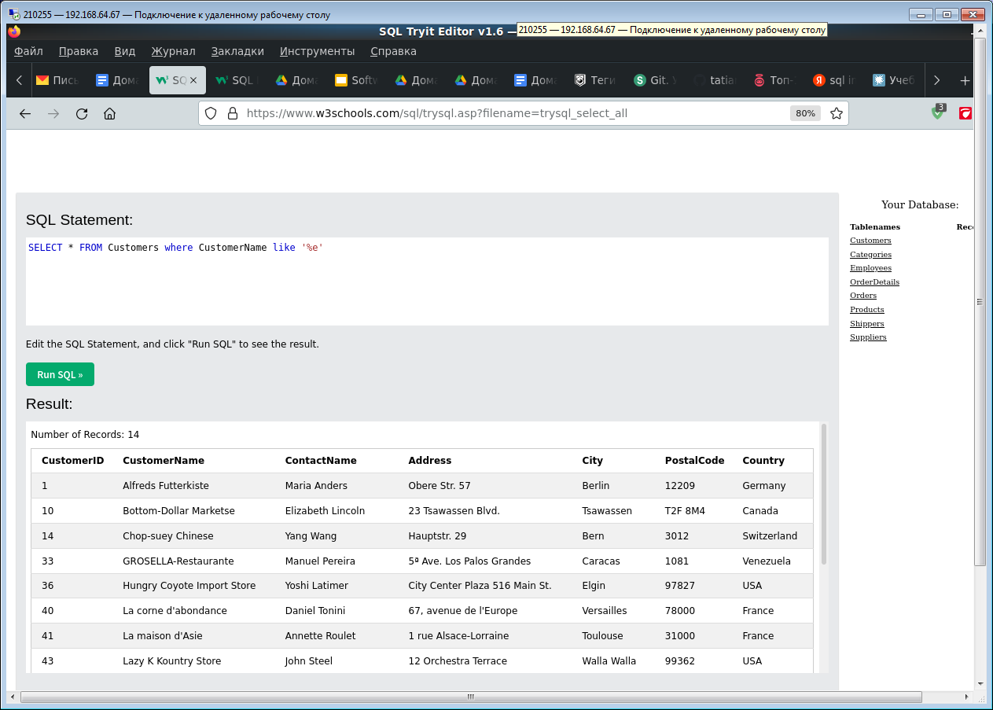

3.

Insert into Customers (CustomerName) values ('Shushakova')

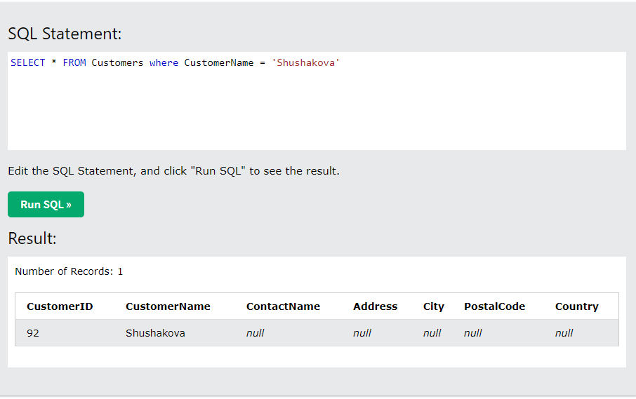

4.

Update Customers Set CustomerName = ‘Tatiana Shushakova’ where CustomerID = ‘92’

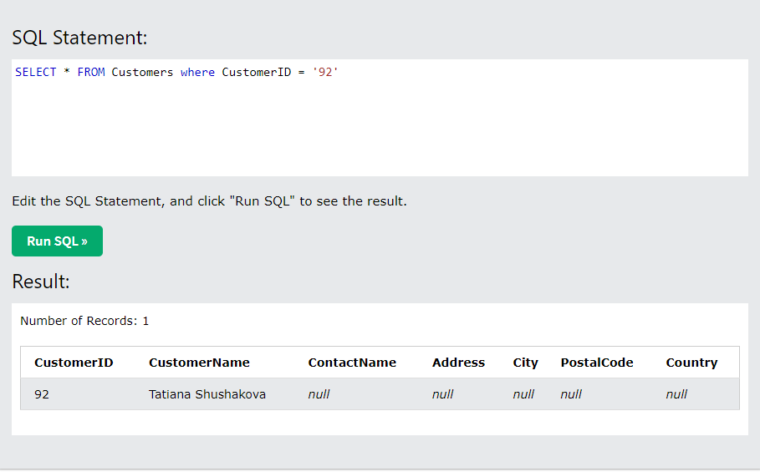

5.

Delete FROM Customers where City = 'Nantes'

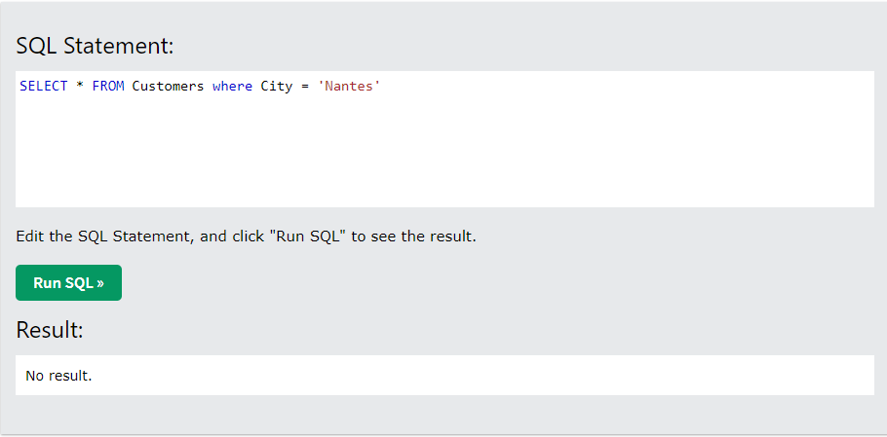

6.

SELECT Orders.orderID, Employees.FirstName FROM Orders

inner join

(SELECT \* FROM Employees where FirstName = 'Steven'

) Employees

on Orders.EmployeeID = Employees.EmployeeID

